80.06.30
To John Shillinglaw
MS Box 57, Memorial to John Batman, Shillinglaw papers, State Library of Victoria.
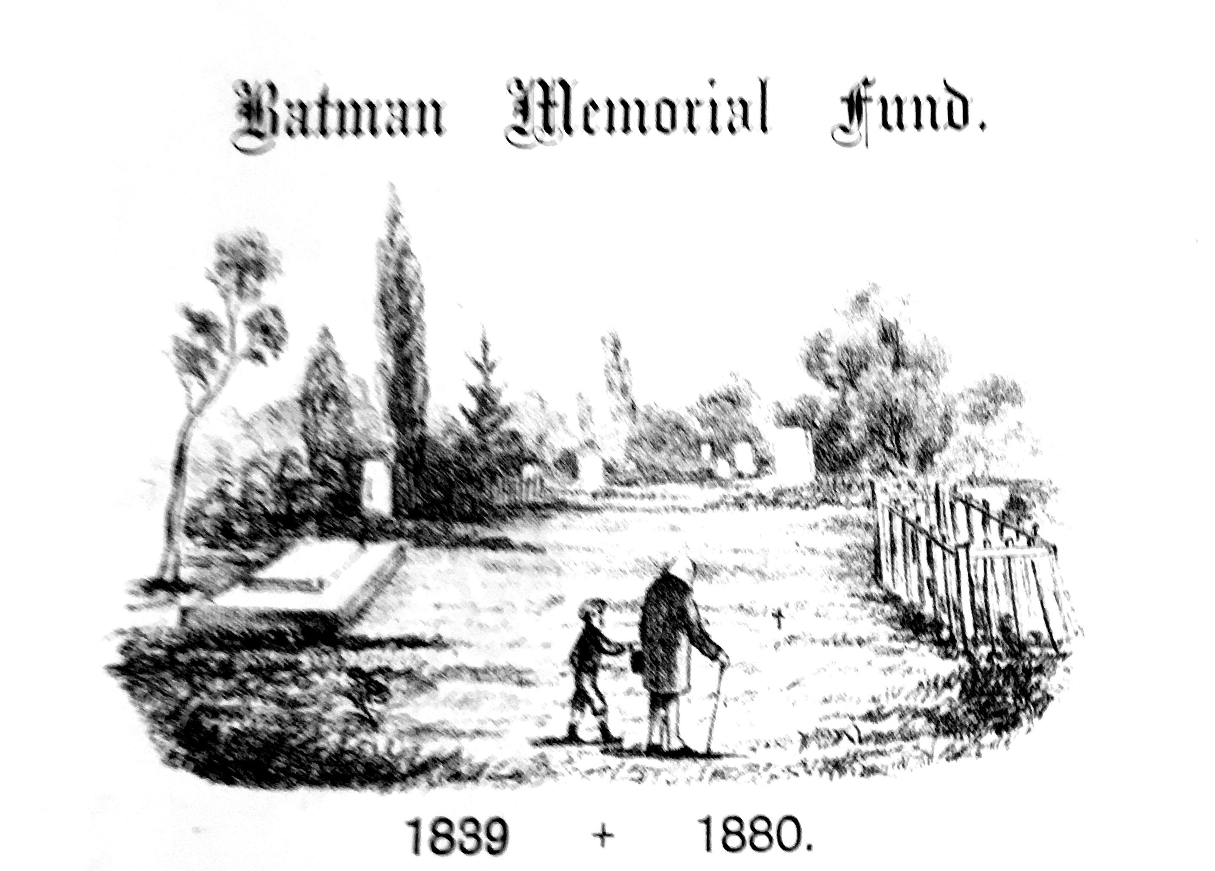

Subscription List issued to Members of the Committee. To be returned by 30th June, 1880.
To Sir Ferdinand von Mueller, FRS &c.

C. A. Groener | 1/
J. Noard | 1/
C. Troedel | 1/
J. G. Luehmann | 1/
C. M. Hach | 1/
J. Caro | 1/
H. Wertheim | 1/
N. Roman | 1/
N. Kreitmeyer | 1/
B. Simmonson | 1/
E. Schaefer | 1/
W. A. Brahe | 1/
R. Nell | 1/
W. Enes | 1/
W. Wisher | 1/
G. Schlemm | 1/
Dr Schleicher | 1/
A. Kleiser | 1/
B. Syme | 1/

There is a pictorial letterhead: 80-06-30_image01.jpg The item is dated to 30 June 1880 on the assumption that M would have returned the list of people from whom he had garnered subscriptions by the due date. The Memorial Committee was formed and the subscription set at one shilling at a meeting in the Melbourne Town Hall on 11 May 1880 ('Batman Memorial Fund', Argus, 12 May 1880, p. 7). Shillinglaw was elected Secretary, and it is assumed that it was he who distributed blank subscription lists to members of the Committee and to whom completed lists were to be returned. M was one of the 70 supporters appointed to the Committee.
Wischer?
The first four names are signatures, the remainder have been entered in an unknown hand. An additional name has been almost entirely cut off from the bottom of the sheet, probably during the binding of the memorial volume in which the MS is incorporated. M's signature as a donor appears on the subscription list issued to Robert Hoddle that is also included in the bound volume; the amount of his donation is not indicated.

